Recently, we learned about types of regression, or the measure of the relationship between two different variables. Regression functions can take multiple forms, whether it be linear, exponential, or even sigmoidal. It is useful for extracting trends from data only if said data can easily be modeled by an existing model, so then what happens when the data we are trying to model forms a function that is much too complex? Each one of those models would no longer be a good fit on its own. We would need to use a different metric, then, to extract any trends; one good alternative is the moving average. I will discuss the difference between the moving average and rolling mean (the latter is a subset of the former).

Moving averages are defined as averages of *overlapping regions* in a time series. The series is divided into overlapping windows of a user-defined size and the average value is calculated for each window. Moving averages not only visualize the trend of complex functions, but also smooth out noise in the data, working as a sort of opposite to jittering. More often than not, it is used by market analysts and stock traders alike to determine the direction of a market and to determine the trend of their securities and stocks via this noise smoothing. There are two main types of moving averages: Simple moving averages and exponential moving averages.

The simple moving average (SMA), also known as the *rolling mean*, is a subset of moving averages that is the easiest to compute for a time series. It consists of sampling an average from a time series across windows of a user-defined length. The equation can be defined as SMA = sum(A)/n, where A is a vector containing the time points in our window and n is the length of the window. For example, if one sets a window size of 5, then the first 5 time points will be averaged into one average. Since it takes an average per shifted window, there is no moving average value for the first n-1 values. Every subsequent point after 5 pushes out the point at the end of the average window so that there are always n number of values in the average; in this way, the average “shifts” forward in the time series. Below is an example of a simple moving average for a website that logs number of pages visited per session. We can see this is a 7 point SMA, and as such, the first 6 values for SMA will be blank and the window always contains 7 values shifting down one each iteration.

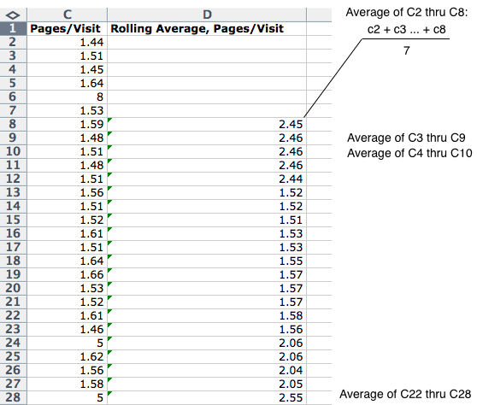

The exponential moving average (EMA) is similar to the SMA though it is slightly more complicated to calculate. Its equation is defined as EMA = (price - EMA(i - 1))*p + EMA(i - 1) , where EMA(i - 1) is the previous value of the EMA and p is a multiplier defined as 2/(n + 1). Because the equation depends on the previous EMA value, the first one is defined as the SMA.

The main difference between the two moving averages is in the weighting of the values. The SMA applies an equal weighting to all the values within its window while the EMA assigns a higher weight to the most recent values in the window. In this way, the EMA is more sensitive to price changes, passing through support and resistance levels much easier (i.e., price levels predicted to be a price floor and ceiling, respectively). Consequently, EMA values require very large windows to be accurate (>250), something that can only be applied to time series with either large histories or large sampling rates.

References:

https://corporatefinanceinstitute.com/resources/knowledge/other/moving-average/

https://www.investopedia.com/terms/m/movingaverage.asp

https://www.investopedia.com/articles/trading/10/simple-exponential-moving-averages-compare.asp

https://school.stockcharts.com/doku.php?id=technical_indicators:moving_averages